|  |
| --- |
| Practical no. .10  Title of the Assignment: Data Visualization Ill  Download the Iris flower dataset or any other dataset into a DataFrame. (e.g. , https://archive.ics.uci.edu/ml/datasets/lris ) . Scan the dataset and give the in  1. List down the features and their types (e.g. , numeric, nominal) available in 2 . Create a histogram for each feature in the dataset to illustrate the feature  3 . Create a box plot for each feature in the dataset.  4. Compare distributions and identify outliers. |

In [

|  |  |  |
| --- | --- | --- |
|  | |  | | --- | | import pandas as pd import matplotlib.pyplot as PI t import seaborn as sns from sklearn . datasets import load iris iris = load_iris() pd.DataFrame(iris.data, columns=iris . feature_names) species  pd. Categorical.from_codes(iris.target, iris . target_names) df.drop( species ' axis=l) .  figsize=( plt.suptitle( 'Histograms for Each Feature' fonts1ze-16) PI t . show() | |

Histograms for Each Feature

sepal length (cm) sepal width (cm}

16

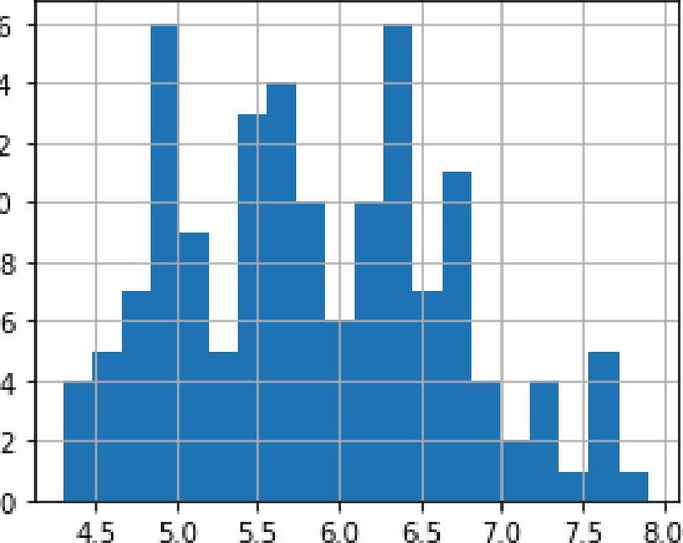

6.0

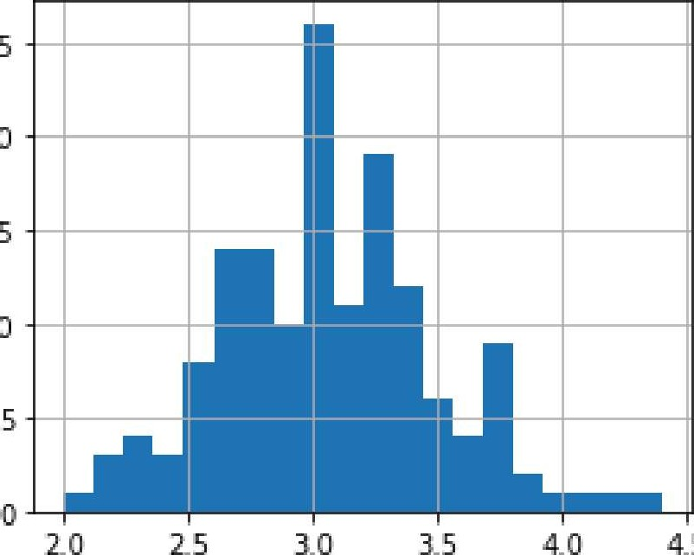

3.0

4_5

25 14 1220

# 10

15

10

petal length (cm) petal width (cm)

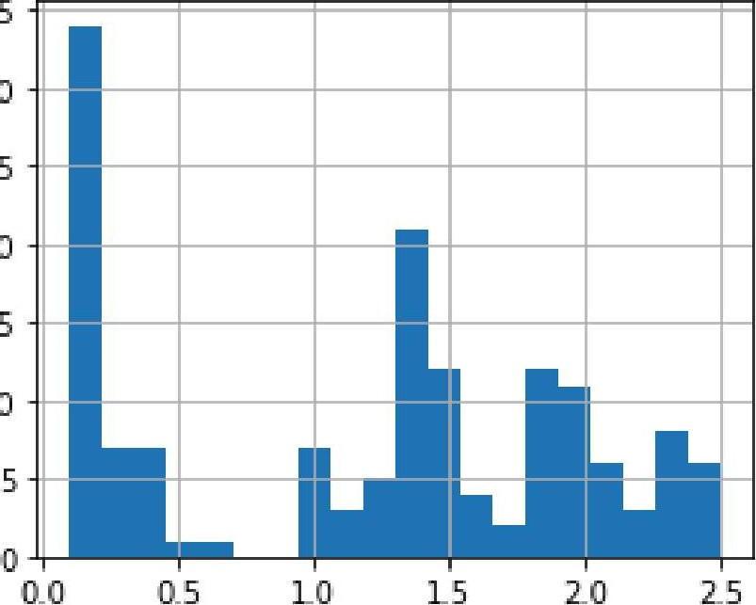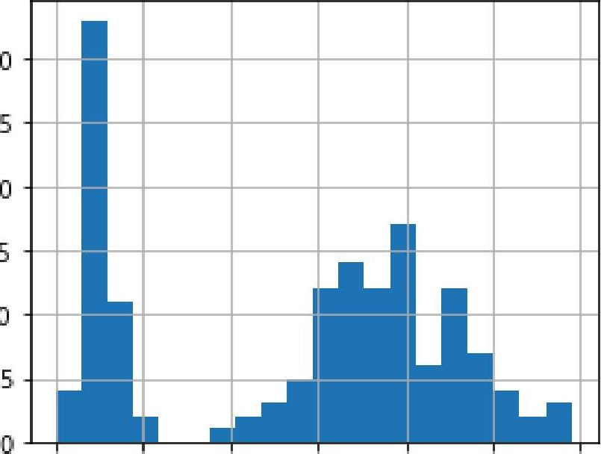35

30

30

2525

2020

1515

# 1010

1 2 3 4 5 6 7

PI t . figure (figsize=(12, 8) ) sns . boxplot (data=df . drop( species ' axis-I)) plt .title( 'Box Plot for Each Feature l PI t . show()

Box Plot for Each Feature

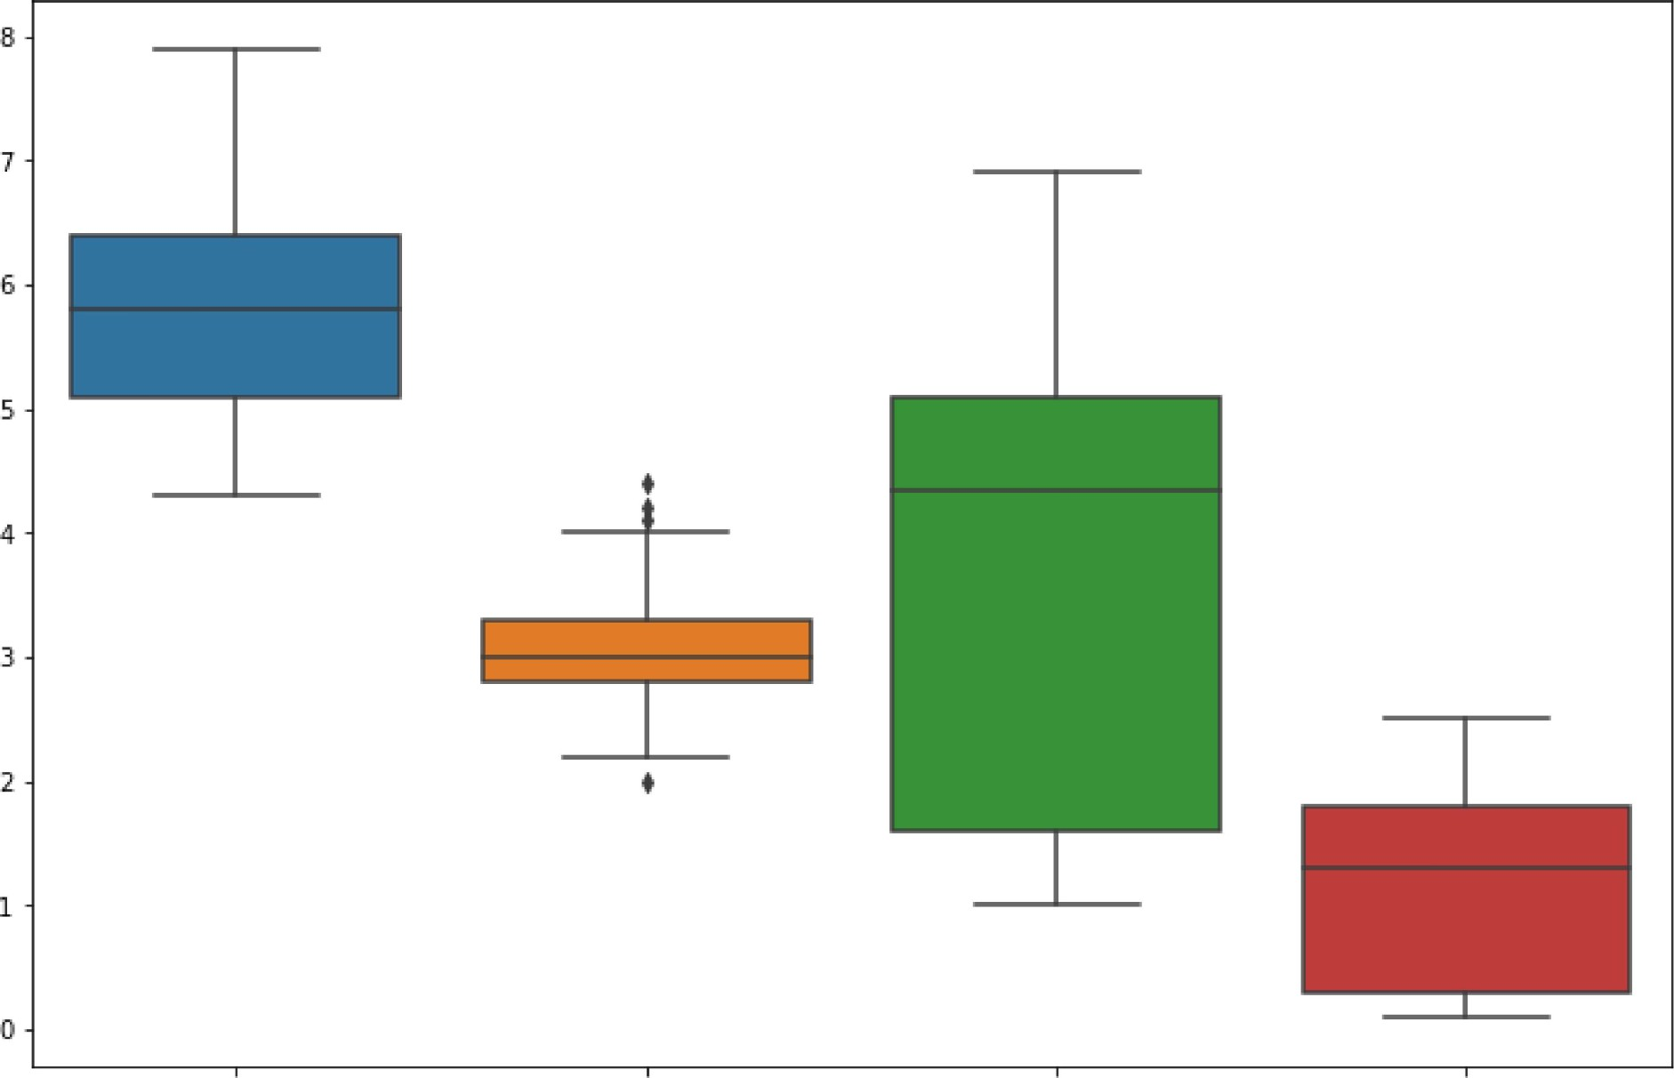

sepal length (cm) sepal width {cm} petal length {cm} petal width (cm)

|  |  |  |
| --- | --- | --- |
|  | |  | | --- | | Name: Mansi Nirbhavane  Roll no: 13251 | |